Liquid Soap Manufacturing Process: Integration with Initial Condition

Let us consider a manufacturing process that produces liquid soap. Hot liquid soap enters the cylindrical storage tank by means of an entry pipe. The storage tank serves as a reservoir to hold the liquid soap until it cools to room temperature. Once the liquid soap cools to room temperature the storage tank is emptied and its contents are sent to another process where the liquid soap is bottled, packaged and sent off to market. This situation is illustrated in the Figure below.

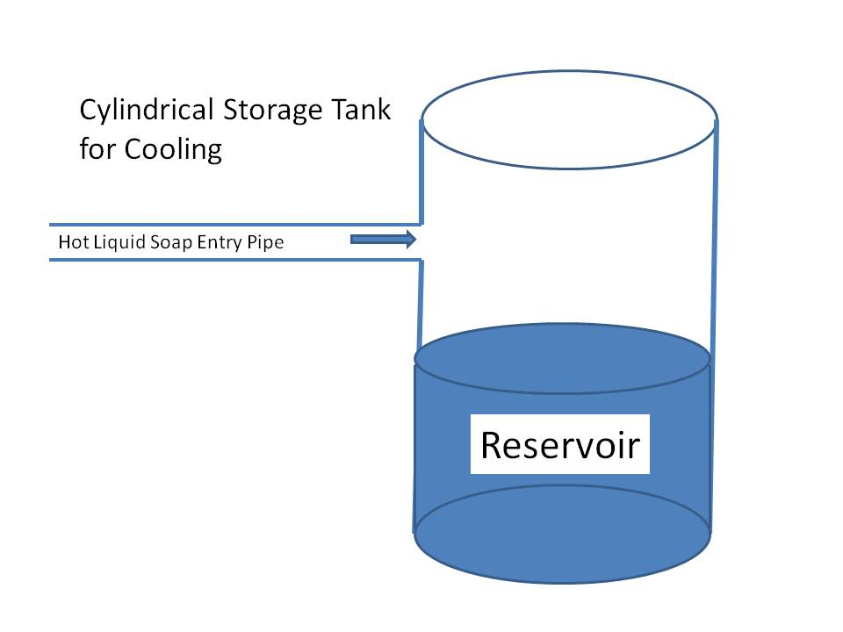

***Problem Statement***: The factory can produce and fill the storage tank with liquid soap at a flow rate (*F*) of 500 liters/hour. Suppose that initially, the tank holds 10,000 liters of liquid soap. How long will it take for the volume of liquid soap in the storage tank to reach a value of 20,000 liters?

For this manufacturing process, the volume (*V*) of liquid soap present in the tank is the integral of the flow rate (*F*).



Thus *V* is the antiderivative of *F*. For our problem the value of *F* is 500 (liters/hour). We can introduce this into our expression and determine the indefinite integral as



We know that the tank initially stores 10,000 liters of liquid soap. We can establish the value of time at which the initial volume is 10,000 liters as *t* = 0 for our process. Therefore, we can express the volume of liquid soap in the reservoir at time t using the definite integral



Here, we have taken the liberty to express the volume as a function of time. We have also introduced the variable of integration, τ.



We now proceed to determine the value of the constant, *c*. We know that when *t* = 0, the volume *V*(0) of liquid soap in the reservoir is 10,000 liters. If we let *t* = 0 in the expression for *V*(*t*) , we can proceed to solve for the value of *c*.



Thus we conclude that the value for c is nothing more than the initial volume of the reservoir. We can incorporate it into the expression for volume, *V*(*t*)



Recall, the problem requires that we determine the time when the volume of liquid soap in the tank reaches 20,000 liters. We can find this by determining the value for *t* that makes *V*(*t*) equal to 20,000.



Thus, the volume of liquid soap in the reservoir will increase to 20,000 liters at a time **20 hours** after the time when the volume is initially 10,000 liters.