**Maximizing the Power Transferred to a Load Resistance in an Electric Circuit**

[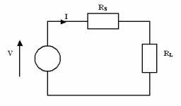](http://upload.wikimedia.org/wikipedia/commons/b/bd/Maxpowertheorem.png)

In the circuit shown, we observe a voltage source *V* and a fixed source resistance, *RS*, which is attached to a load with resistance, *RL*. Power is transferred from the voltage source to the load resistance.

The current, *I*, that flows in the circuit can be found by applying Ohm’s Law. The current, *I*, is simply the ratio of the source voltage, *V*, to the total resistance of the circuit, *RS* + *RL*. Stated mathematically,



The power that is delivered to the load is the square of the current multiplied by the load resistance,

.

Suppose that the values of *V* and *RS* are fixed (constant). Suppose that the value of load resistance is to be chosen by a design engineer in such a way that the power delivered to *RL* is maximized. Under these circumstances, we may express the power delivered to the load as a function of *RL*,

.

At this point, we elect to find the derivative of *P*(*RL*) with respect to *RL*.



For physical resistances, the value for *RL* will be positive. Thus, we are assured that the denominator will not be zero.

We next solve for the value of *RL* that makes the derivative equal to 0. We can do so by determining the value for *RL* that makes the value of the numerator of the above expression zero.



Because physical resistances are always positive, we conclude that we should choose the value of ***RL*** to be equal to the value of ***RS*** in order to achieve maximum power transfer to the load resistance.

The plot below shows a plot of the power transferred to the load resistance as a function of the ratio (*RL*/*RS*). From the plot, we clearly identify that maximum power is transferred when the ratio *RL*/*RS* is unity. This agrees with the result obtained through our analysis based on the derivative.

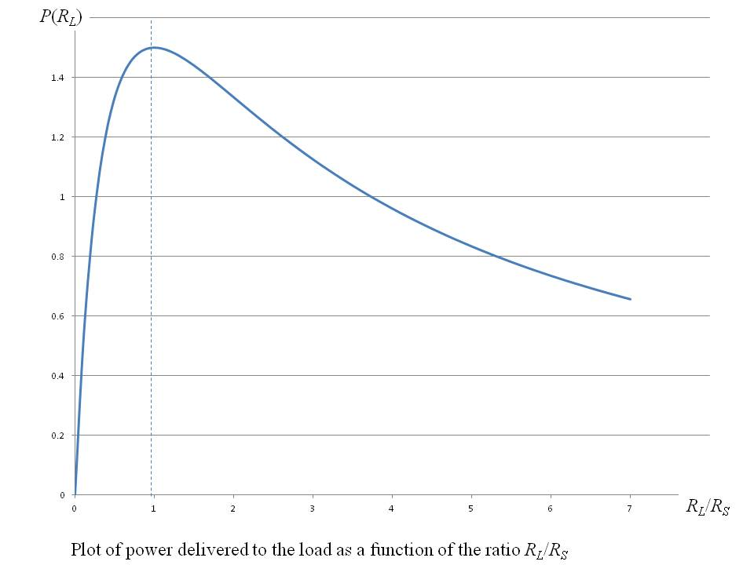

Maximum power transfer from source to load is an important concept in designing electrical systems. Therefore, the result that the ***load resistance should be equal to the source resistance*** is frequently used in the design of electrical systems.