Dr. Lesser A CHANCE FOR YOU TO “EXCEL” !!! ☺

Brief background: A spreadsheet cell can have function commands (which always start with an equals sign), text, or numbers. The cell that’s in column A and row 3 is referred to as A3. The rectangle containing cells A5, A6, and A7 is referred to as A5:A7. The 8-cell rectangle whose top left entry is A1 and bottom right entry is B4 is referred to as A1:B4. If you have questions about spreadsheets, ask!

This handout is tailored to the current version of Microsoft Excel (2010).
If you have an older version (or a MAC version), some details will be different.

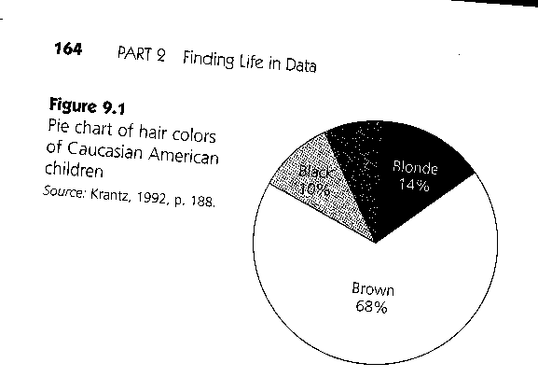

PART ONE: One variable that is qualitative(categorical)

Let’s recreate the figure above and assume it was created from a sample of 100 people. Open a fresh spreadsheet page. In cell A1 enter BLACK. In A2, enter RED. In A3, enter BLONDE. In A4, BROWN. In cells B1, B2, B3, B4, enter 10, 8, 14, 68, respectively. Select the 8-cell rectangle denoted A1:B4.

Click on the INSERT tab at the top menu and then click on the BAR icon (it looks like a multi-colored horizontal bar graph). Once you do that, a menu with the types of bar graph that you can choose from will appear (you can choose from two dimensions, three dimensions, cylinders, cones, pyramids, etc). [Note: you should generally avoid 3-D versions of bar charts because it can be difficult to accurately read or compare heights of the bars.] Then, you can go to the tab LAYOUT and change the chart title, axis title, the legend, data labels (labels for each one of your points in the chart) and even add a data table at the bottom of your chart. You can also change the design of your chart by clicking on the DESIGN tab (by clicking on Quick Layout and Quick Styles icons).

Once the graph is made, you can still modify your graph by clicking on it, going to the LAYOUT tab, and choosing the things that you want to change.

Now, select the A1:B4 data again, click on INSERT tab, and try a pie chart. [Note: you should generally avoid 3-D versions of pie charts (especially “exploding” ones) because they are distracting by giving extra emphasis to the part of the pie nearest the viewer.]

Once you have a graph/chart, you can click near the chart to make black boundary squares appear. These can be dragged to resize the chart. The graph can be copied and pasted into a Microsoft Word document.

====================================================
PART TWO: One variable of quantitative (measurement) data

Open up a NEW blank spreadsheet in EXCEL; click on the icon at the top left corner that has four colored squares (it is often called the Microsoft Office button), then NEW, choose the BLANK AND RECENT option, and create (at the bottom of the menu).

Down column A (in rows 1 through 28), start entering these 28 numbers (“classroom test score data”):
75, 95, 60, 93, 85, 84, 76, 92, 62, 83, 80, 90, 64, 75,
79, 32, 78, 64, 98, 73, 88, 61, 82, 68, 79, 78, 80, 55

- Click on the “A” over column A to select column A. Then click on the Sort And Filter icon and the option Sort Smallest to Largest (A→Z) to arrange the data in order so that the smallest value is in A1. Can you find the minimum, maximum and median easier now?

2.) Let’s find the 50th percentile of this dataset. Click on an empty cell (e.g., B1) and type in =PERCENTILE(A1:A28, .50) and then hit ENTER. Is the answer equal to the median? (Note: starting with the equals tells EXCEL you’re entering a specific EXCEL command, not just text.)

- Let’s find out the standard(z) score of the value in A1. (A z-score means “how many standard deviations above the mean you are”) To do that we need to know the mean and the standard deviation of the observations. Click on an empty cell (e.g., B2) and type in =STDEV(A1:A28) and hit ENTER. Click on another empty cell (e.g., B3) and type in =AVERAGE(A1:A28). Now in another empty cell (e.g., B4), type: =(A1-B3)/B2 or =STANDARDIZE(A1, B3, B2)

How many standard deviations above the mean is the value in A1? Is the value in A1 an “outlier”? [Note: if you wanted to find the z-score of all the values, the easy way is to enter this in C1: =(A1 – 76)/14. Now select C1 and hover the cursor over the lower-right corner of C1 until it changes from a thick white plus to a thin black plus. Click and drag down the column to C28.]

- Now from the DATA tab, click on Data Analysis. [If it’s not there, do this first: go to the File menu and then click Excel Options. Click Add-Ins, and then in the Manage box (near the bottom) select Excel Add-Ins and click GO. In the “Add-Ins available” box, choose the “Analysis ToolPak” and then click OK.]

Choose Descriptive Statistics, and for input range type A1:A28. Click Output Range and type in the cell that could be the top left corner of the output without writing over something already there. How about D1? Put a checkmark for Summary statistics and click and a confidence interval for mean of 95%. Now click OK. (If you can’t read all the headings in column D, you can drag the double-headed arrow that appears when you hover over the border between column headings.) What terms in the output do you recognize?

- In B6, enter 40. In B7, enter 50. In B8, enter 60. In B9, enter 70. In B10, enter 80. In B11, enter 90. In B12, enter 100. These are the (upper) limits of each numerical “bucket” or bin. From the Data menu, select Data Analysis, choose Histogram. Let input range be A1:A28, and let bin range be B6:B12, let the upper left corner of the output range be F1, and click on Chart Output. Click OK. You can change its size for readability.

PART THREE: two variables of quantitative(measurement) data

Remember that using technology to work with regression models is part of the TEKS!

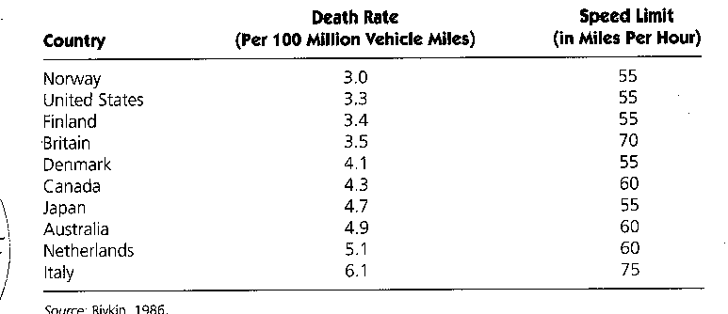

Start a new spreadsheet page. In A1 enter the text SpeedLimit (X). In B1 enter the text DeathRate (Y). In A2:A11, enter the numbers: 55,55,55,70,55,60,55,60,60,75.
In B2:B11, enter the numbers in the middle column:
3.0, 3.3, 3.4, 3.5, 4.1, 4.3, 4.7, 4.9, 5.1, 6.1.

- Select A2:B11, choose INSERT – Scatter. Choose the type of scatter-plot that you want and add the title and axis labels (go to Layout tab and make the modifications). What kind of correlation would you guess this plot has? (recall that correlations are numbers between -1 and +1, where perfect negative correlation is -1, perfect positive correlation is +1, and no linear correlation is a value of 0). Let’s find the numerical value of the correlation. In an empty cell, type =CORREL(A2:A11,B2:B11). What value do you get?

- Let’s find the slope of the line of best fit. Are you expecting a positive or negative value? In an empty cell, type =SLOPE( and notice how EXCEL prompts you for one of the variables to be entered before the other one. You’ll get a different answer if you don’t follow the order it asks for. For the y-intercept, find an empty slope and use the command =INTERCEPT( and use the same order to finish it off.

[note: Another way to get the correlation value and the slope and intercept coefficient numbers is to choose the Regression from the Data Analysis option under the DATA tab, but you’ll be pulling “Multiple R” and “coefficients” values out from a whole lot more output to sort through.]

- Now, let’s add the line of best fit to the scatter-plot we already have. Right-click on one of the points in the scatter-plot and choose Add Trendline, then from the options choose Linear and then Close. Does this line look consistent with the slope and intercept values you found?

- Look at the scatter plot again – what country appears to be an “outlier”? Redo the correlation command with the outlier country deleted and see how that changes the correlation value.

PART FOUR: Picking a sample

Suppose you wanted to select 10 items from the numbers 1-30 (or imagine a list of 30 names on your class roster that are numbered 1-30). On a new spreadsheet page, enter the numbers 1-30 in A1:A30. A fast way to do this: enter 1 in A1, 2 in A2. Click on the middle of A1 and drag down to A2 so that both A1 and A2 are selected now. Now hover over the lower right corner of A1:A2 so that the cursor goes from a large white plus to a thin black plus. Now click and drag down all the way to A30. Was EXCEL “smart enough” to continue the arithmetic sequence? Okay, from the Data Tab choose Data Analysis, then Sampling. Input range A1:A30, random 10 samples, output range C1. (Note: other sampling schemes can be generated from the Random Number Generation option of Data→ Data Analysis).

