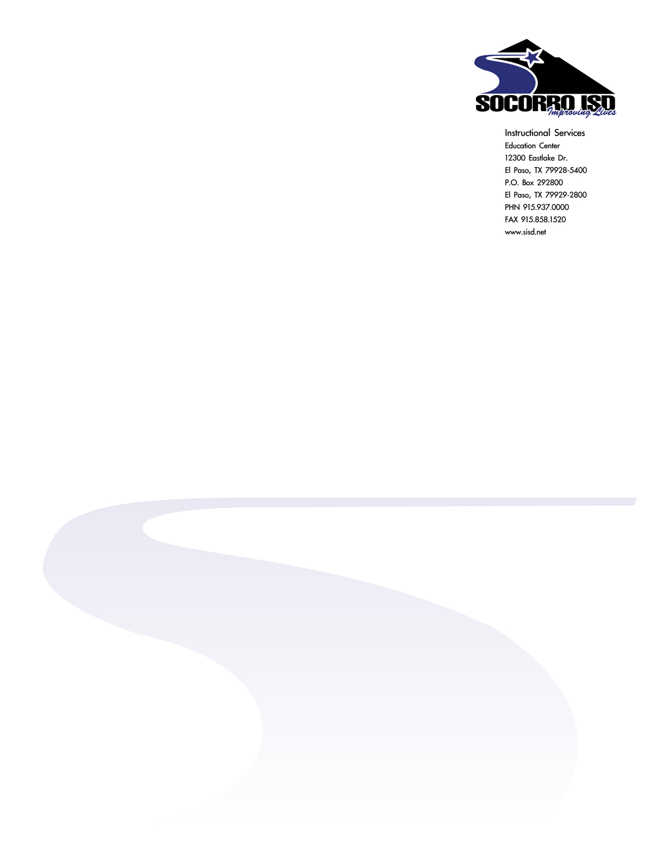

Request for Research

All requests for research projects will be submitted in writing to:

Dr. Nidelia Montoya
Director of Research and Analysis
Socorro ISD
12300 Eastlake
El Paso, TX 79928
(915) 937-0305
Fax (915) 937-0333
Email nmonto@sisd.net
Requests shall include:

- Brief statement of the purpose of the project.
- Timeframe within which research will be conducted in the District.
- Anticipated benefit to the District.
- Statement indicating how data collected will be used.
- Assurances of confidentiality of participants and anonymity of responses.
- Any anticipated risks to participants or the District.
- Anticipated cost or burden in time and money to participants and the District.
- Statement that participation by individuals is voluntary and those participants may withdraw at any time.
- Attachments or proposed informed consent forms and questions/surveys, etc. that will be used, as pertinent.
- Name of the Principal Researcher(s), address(es), and telephone number(s) and any other means of communication such as fax numbers and/or email address(es).
11. Signatures of the Principal Researcher(s).

